PROJECT REPORT: SECURE INTER-VLAN ROUTING & NETWORK HARDENING FOR A CORPORATE OFFICE
Student Name: Azka Anwar Ali Sayed
Project Title: Implementation of Secure Inter-VLAN Routing with Security Hardening using Cisco Packet Tracer

1. Executive Summary & Project Goal

The Main Goal
The goal of this project is to build a modern, secure corporate network for an office with two main departments: Human Resources (HR) and Information Technology (IT).

The Problem We Solved
If all office computers are plugged into a standard switch without separation:
- HR staff and IT staff can see each other's traffic (Security Risk).
- Any computer sending network broadcasts slows down all other computers (Performance Risk).
- Anyone walking into the office can plug an untrusted laptop into a wall socket and join the network (Physical Security Risk).

The Solution We Built
To fix these issues, we used Cisco Packet Tracer to construct a segmented, hardened network:
- VLANs (Virtual LANs): Digitally split the switch into separate virtual rooms for HR and IT.
- Router-on-a-Stick: Used a single router link to safely transfer packages (packets) between HR and IT when authorized.
- Security Hardening: Locked down the unused switch ports, protected ports against unknown devices (Port Security), moved administrative traffic away from default pathways (Native VLAN 99), and encrypted remote login access (SSH Version 2).

2. Network Layout & Address Planning
To keep the network structured, every device was assigned a specific role, VLAN ID, and IP address range.

VLAN Allocation Table
VLAN ID | Name / Purpose | Function
VLAN 10 | HR | Private network for Human Resources staff
VLAN 20 | IT | Private network for Information Technology staff
VLAN 99 | MANAGEMENT | Secret channel for admins to manage router & switch
VLAN 999 | UNUSED_PARKING | Dead room where unused ports are locked

IP Addressing Table
Device Name | Port Connection | IP Address | Subnet Mask | Default Gateway
HR-PC1 | Switch Fa0/2 | 192.168.10.11 | 255.255.255.0 | 192.168.10.1
HR-PC2 | Switch Fa0/3 | 192.168.10.12 | 255.255.255.0 | 192.168.10.1
IT-PC1 | Switch Fa0/4 | 192.168.20.11 | 255.255.255.0 | 192.168.20.1
IT-PC2 | Switch Fa0/5 | 192.168.20.12 | 255.255.255.0 | 192.168.20.1
SW1 (Switch) | VLAN 99 Interface | 192.168.99.2 | 255.255.255.0 | 192.168.99.1
R1 (Router) | GigabitEthernet 0/0.10 | 192.168.10.1 | 255.255.255.0 | N/A (HR Gateway)
R1 (Router) | GigabitEthernet 0/0.20 | 192.168.20.1 | 255.255.255.0 | N/A (IT Gateway)
R1 (Router) | GigabitEthernet 0/0.99 | 192.168.99.1 | 255.255.255.0 | N/A (Mgmt Gateway)

3. Step-by-Step Implementation Guide & Command Breakdown
Here is the exact step-by-step procedure used to build the lab, along with an easy explanation of every command.

Step 1: VLAN Creation & Port Assignment (Switch SW1)
Why we did this: Switches by default put everyone into one big group (VLAN 1). We created separate groups so HR and IT are isolated.
enable
configure terminal
vlan 10
name HR
vlan 20
name IT
vlan 99
name MANAGEMENT
vlan 999
name UNUSED_PARKING
exit

interface range fastEthernet 0/2 - 3
switchport mode access
switchport access vlan 10

interface range fastEthernet 0/4 - 5
switchport mode access
switchport access vlan 20
end
write memory

Easy Command Breakdown:
- vlan 10: Creates a new virtual network named 10.
- name HR: Names the VLAN "HR" so network engineers know who uses it.
- interface range fastEthernet 0/2 - 3: Selects switch ports 2 and 3 at the same time.
- switchport mode access: Configures the port to talk to a standard single device (like a computer).
- switchport access vlan 10: Locks ports 2 and 3 inside VLAN 10.

Step 2: Router-on-a-Stick Routing (Router R1 & Switch SW1)
Why we did this: Because VLAN 10 and VLAN 20 are completely separated, they cannot talk to each other. We connected one main trunk line from Switch port Fa0/1 to Router port Gi0/0 and split the router port into virtual sub-doorways (subinterfaces).

Switch Trunk Config (SW1):
configure terminal
interface fastEthernet 0/1
switchport mode trunk
end
- switchport mode trunk: Converts port Fa0/1 into a trunk highway that can carry packets for all VLANs simultaneously across a single wire.

Router Subinterface Config (R1):
enable
configure terminal
interface gigabitEthernet 0/0
no shutdown

interface gigabitEthernet 0/0.10
encapsulation dot1Q 10
ip address 192.168.10.1 255.255.255.0

interface gigabitEthernet 0/0.20
encapsulation dot1Q 20
ip address 192.168.20.1 255.255.255.0
end

Easy Command Breakdown:
- no shutdown: Turns on the main router cable port (lights up green).
- interface gigabitEthernet 0/0.10: Creates a virtual sub-interface dedicated to VLAN 10.
- encapsulation dot1Q 10: Tells the router to read 802.1Q color tags so it recognizes traffic belonging to VLAN 10.
- ip address 192.168.10.1 255.255.255.0: Sets the default gateway IP address that HR PCs use to send messages out of their network.

Step 3: Native VLAN Migration & Management (SW1 & R1)
Why we did this: Hackers often target default VLAN 1 for "VLAN Hopping" attacks. We changed the untagged trunk highway door (Native VLAN) and administrative IP to VLAN 99.

Router (R1):
interface gigabitEthernet 0/0.99
description MANAGEMENT-GATEWAY
encapsulation dot1Q 99 native
ip address 192.168.99.1 255.255.255.0

Switch (SW1):
interface fastEthernet 0/1
switchport trunk native vlan 99
switchport trunk allowed vlan 10,20,99

interface vlan 99
ip address 192.168.99.2 255.255.255.0
no shutdown
ip default-gateway 192.168.99.1

Easy Command Breakdown:
- encapsulation dot1Q 99 native: Assigns VLAN 99 as the main native trunk language.
- switchport trunk allowed vlan 10,20,99: Blocks all unwanted VLANs from entering the trunk highway (Trunk Pruning).

Step 4: Disabling Unused Switch Ports (SW1)
Why we did this: If an empty wall socket in an office is active, anyone can plug in an unauthorized device. We disabled all 19 unused ports and threw them into a dead room (VLAN 999).
configure terminal
interface range fastEthernet 0/6 - 24
switchport mode access
switchport access vlan 999
shutdown

interface range gigabitEthernet 0/1 - 2
switchport mode access
switchport access vlan 999
shutdown
end

Easy Command Breakdown:
- shutdown: Electrically turns off the port so no data or power passes through.
- switchport access vlan 999: Assigns disabled ports to an isolated parking lot VLAN with no router access.

Step 5: Port Security with Sticky MAC Addresses (SW1)
Why we did this: We told the switch ports to memorize the unique hardware address (MAC address) of our official office PCs. If an attacker unplugs an office PC and connects their laptop, the port shuts down instantly.
configure terminal
interface range fastEthernet 0/2 - 5
switchport port-security
switchport port-security maximum 1
switchport port-security mac-address sticky
switchport port-security violation shutdown
end

Easy Command Breakdown:
- switchport port-security: Turns on security guard mode on ports 2 through 5.
- switchport port-security maximum 1: Allows only 1 device per port.
- switchport port-security mac-address sticky: Automatically reads and saves the PC's MAC address to memory.
- switchport port-security violation shutdown: Turns off the port completely if an unknown MAC address plugs in.

Step 6: Enforcing SSH Encrypted Access (SW1 & R1)
Why we did this: Old management systems like Telnet send passwords in plain text over the network cable. SSH scrambles (encrypts) all data so eavesdroppers see only gibberish.
configure terminal
ip domain-name lab.local
username admin secret YourStrongPass1
enable secret YourStrongPass2
service password-encryption
crypto key generate rsa
1024
ip ssh version 2
line vty 0 4
transport input ssh
login local
exit
banner motd #Authorized access only. Violators will be prosecuted!#
end

Easy Command Breakdown:
- crypto key generate rsa: Creates a mathematical 1024-bit encryption key lockbox.
- ip ssh version 2: Sets the switch to use modern, unbreakable SSH version 2.
- transport input ssh: Blocks unencrypted Telnet completely, permitting only SSH logins.

4. Screenshot Evidence & Verification Guide

Screenshot S1: Topology Setup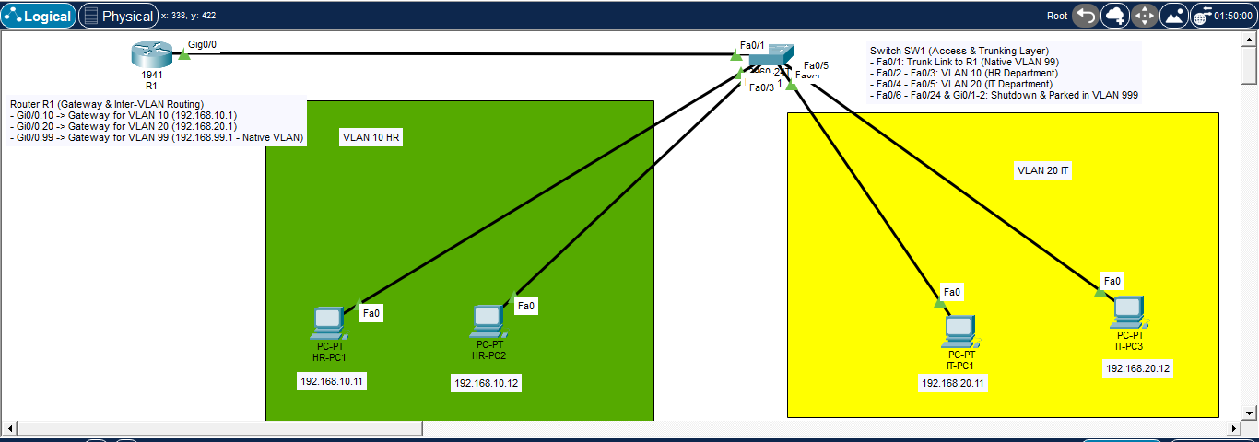
- What it proves: Shows R1, SW1, and 4 PCs connected with active green link lights.
- Explanation: "This screenshot verifies the complete physical layout of our topology. Green indicators confirm that cabling and physical ports are online."

📸 Screenshot S2: Switch VLAN Summary (show vlan brief) 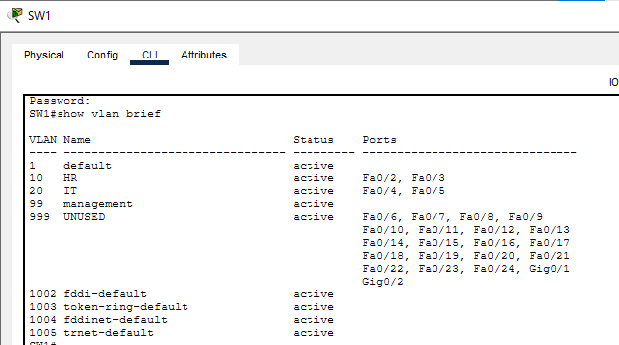
- What it proves: Displays VLAN 10 (HR), VLAN 20 (IT), VLAN 99 (MANAGEMENT), and VLAN 999 (UNUSED_PARKING).
- Explanation: "This proves that logical network separation is active on SW1 and ports Fa0/2–Fa0/5 are correctly assigned to their respective departments."

Screenshot S7: Router Routing Table (show ip route) 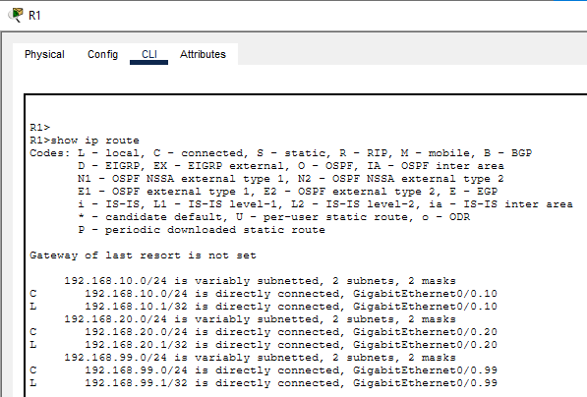
- What it proves: Shows subnets 192.168.10.0/24 and 192.168.20.0/24 directly connected via subinterfaces.
- Explanation: "This confirms that Layer 3 routing between VLANs is operational across subinterfaces g0/0.10 and g0/0.20."

Screenshot S13: Trunk & Native VLAN Status (show interfaces trunk)
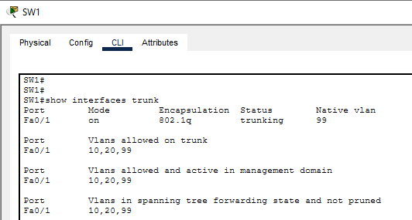
- What it proves: Shows Native VLAN set to 99 and allowed VLAN list limited to 10, 20, 99.
- Explanation: "This confirms native VLAN migration away from default VLAN 1 to prevent VLAN hopping attacks."

Screenshot S16: Disabled Unused Ports (show ip interface brief)
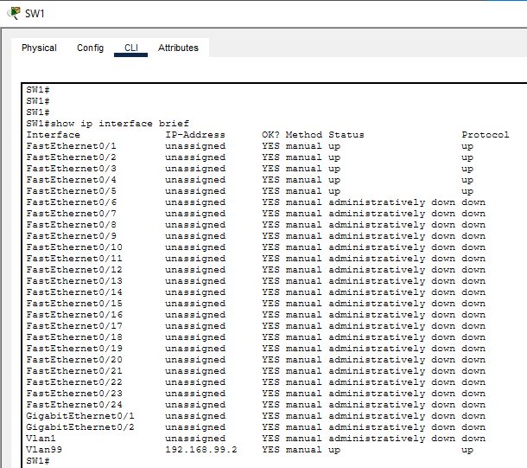
- What it proves: Ports Fa0/6 to Fa0/24 showing state as administratively down.
- Explanation: "This confirms that all empty ports are shut down to prevent unauthorized physical connections."

Screenshot S17: Port Security Status (show port-security interface fa0/2)
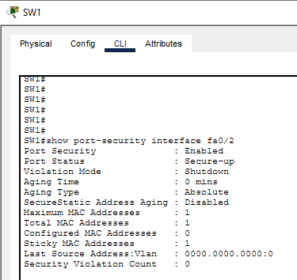

- What it proves: Shows Port Security Enabled, Maximum 1 MAC, Violation mode Shutdown.
- Explanation: "This demonstrates active port security protecting office wall sockets from rogue device attachments."

5. Conclusion & Learning Outcomes

Conclusion
The implemented project successfully demonstrates a high-performance, secure corporate network layout. By pairing VLAN segmentation with Router-on-a-Stick inter-VLAN routing, HR and IT departments can communicate efficiently without compromising security. Furthermore, hardening measures (Port Security, Unused Port Shutdown, Native VLAN migration, and SSH encryption) ensure resilience against common Layer 2 and Layer 3 attacks.

Key Learnings
- How to configure IEEE 802.1Q subinterfaces on Cisco Routers.
- How to manage Layer 2 switch ports and VLAN access lists.
- How to mitigate physical and administrative security risks using standard Cisco IOS hardening commands.

